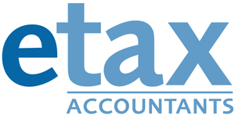

Name:
www.etax.com.au
1300 693 829
LAUNDRY DIARY

Signature: _

Date | Number of Wash Loads | Eligible Clothes only ($1) | Mixed Load (0.50) | TOTAL
e.g. 1 June 2018 | 2 | $1.00 | $0.50 | $1.50
 |  |  | TOTAL

